

ASSET VERIFICATION AND RECORDING TOOL KIT


Plot 31, Bukoto Street
P.O Box 7657, Kampala, Uganda
+256 (0) 39 2000216/0772525235
email: cpa@cpa.ug

www.cpa.com

August to September 2026

VERIFICATION DETAILS

NAME OF THE REGION: | WESTERN REGION
SUB-REGION: | TOORO REGION
Name of Local Government | KABAROLE DISTRICT LOCAL GOVERNMENT
VERIFIER PARTICULARS
Full name | ZALWANGO MARIA,NASSEJJE NADIA,NABBOSSA SUMAYA
Contact/ email and Telephone | 0751977570,0754884004,0708098456
Supervisor/ Sub team leader
Name | DEPAUL MBONIGABA
Contact | 0788483159 depaulrukara@gmail.com
Date of submission

HEALTH CENTRES
INFORMANT INTERVIEW/DISCUSSION GUIDE (INCHARGE OR RESPONSIBLE PERSON)

Name of Health Centre: KIDUBULI HEALTH CENTRE III

1a | Does the Facility have a record of all assets provided under UgIFT.  (Obtain a record and verify if it has the costs and numbers supplied | yes
1b | If Not ask how many were supplied and when.

2 | How does this facility Maintain (repair/service/replace) the assets provided under Ugift

It is maintained by the facility officials/in charge. For example, of recent the facility covered the mattresses with capilas

3 | Does the facility take regular record about functionality/ or breakdown of the assets provided? | Yes they do.  In case of breakage, the one Mariam Jidudu said that they normally use a counter book to record all equipments broken.

4 | How has the UgIFT support helped in service delivery in the area, any issues, challenges and any recommendations for better program implementation. | The UGIFT has consistently helped in supplying health equipements to the facility and this has eased admissions hence managing the overwhelming at the facility.  It has also helped in the accommodations of staff by building staff quarters near the facility. This has reduced absenteeism at the facility since officials are ever present at the facility.  It also minimumly increased the health workers at the facility hence reducing the overwhelming health to patient ratio.  It has also helped in good sanitation because of the increased number of assets at the facility like the placenta pits, pit latrines and bathrooms for patient.  Labor wards and available equipements for labor such as labor beds and labor suits have created enough space for mothers in labor hence reducing congestion.  Because of the available equipements, and assets the facility can now handle overwhelming admissions hence reducing unnecessary referrals. However, the facility has always hard issues and challenges which include:  - The Lab is generally very small hence causing delay in service.  - Inadequate inventory store at the facility and has forced the facility to improvise the men’s ward into a store and the men are now admitted together with ladies in the same female ward.  - Adult beds are not enough. They only have 4 yet averagely on a single day, 70 patients are received.  - Theft and threats attributed to lack of a perimeter fence. Hence putting health officers and patients at stake.  - Stock Outs and delays of restocking is really a big challenge hence hindering admissions and normal treating of the patients.  Notwithstanding,  i. we recommend that the OPD facility be increased to reduce the overwhelming daily admissions at the facility.  ii. we also recommend a perimeter wall to be installed at the facility since they lack one to improve on the security
11

PROCEED TO VERIFICATION AFTER THIS DISCUSSION

Health centre checklist

NAME OF LG MAYUGE DISTRICT LOCAL GOVERNMENT. NAME OF HEALTH FACILITY : KIDUBULI HEALTH CENTER III

Equipment/ Item | Department | Asset Number | Item  Description | Life in Months | Tag Number ( engrave no.) | Date Of Purchase | Date Placed In Service | Recoverable cost | Cost | Acc Dep Cost | Net Book Value | Ytd Deprn | Equipment status | Remarks
B.P. Machine, Digital | health |  | Boxed |  |  |  | 6th/08/2024 |  |  |  |  |  | Received 2 and all still functioning. | All the 2 that were received were verified and are all functioning
B.P. Machine (Aneroid wall mounted) | health |  | Boxed |  |  |  | 6th/08/2024 |  |  |  |  |  | All functioning | All the 2 received were verified and 1 faulty
Autoclave 20 Liters.,Duo Operated | health |  | Silver bowl with a round top and black handles with a gauge. |  |  |  | 6th/08/2024 |  |  |  |  |  | They are in good status | All the 2 were received and verified
Bowl, Kick | health |  |  |  |  |  | 6th/08/2024 |  |  |  |  |  |  | Not Received  Not verified
Bowl Stand | health |  | . |  |  |  |  |  |  |  |  |  |  | They were still in store
Counting chamber Neubauer- Improved |  |  |  |  |  |  |  |  |  |  |  |  |  | Not verified
Cupboard Steel, Lockable | health |  | Grey in color with compartments, lockable in nature |  | Not engraved |  |  |  |  |  |  |  | functioning | verified and all functioning`
Drip Stand
ESR Stand | health |  | Boxed |  | Not engraved |  |  |  |  |  |  |  | Good condition | They were still in store
Examination Couch | health |  | 4 silver stands with a black soft sponge mattress with a lifter |  | Not engraved |  |  |  |  |  |  |  | functioning | 2 received and verified
Examination light,LED | health |  | White in color |  |  |  |  |  |  |  |  |  | functioning | 2 received and veried
Glucometer | health
Haemoglobin Meter, Digital | health |  | Boxed |  |  |  |  |  |  |  |  |  | functioning  2 received | They are in store
Height Meter | health |  | White and black in color
Instrument Trolley | health |  | Silver in color with 2 partitions and 4 black wheels |  |  |  |  |  |  |  |  |  | functioning | 2 verified
Microscope Binocular |  |  |  |  |  |  |  |  |  |  |  |  |  | Not received
Otoscope | health |  | Boxed |  | Not engraved |  |  |  |  |  |  |  | functioning | Verified but just kept
Patient Screen
Patient Trolley
Refrigerator, Basic | Health |  | Grey in color with 2 compartments , the lower one bigger than the upper one |  |  |  |  |  |  |  |  |  | functioning | 1 verified and functioning
Stethoscope | health |  | Boxed |  |  |  |  |  |  |  |  |  | functioning | 4 received
Stop Watch | health |  | Boxed |  |  |  |  |  |  |  |  |  | functioning | 2 received
Stretcher | Health |  | It has 4 black wheels with two rails and a blue soft sponge |  |  |  |  |  |  |  |  |  | All Functioning | 1 seen and verified
Stove, Gas | health |  | White in color, 6kg(stabex) |  |  |  |  |  |  |  |  |  | working | 1 seen and verified
Weighing Scale with Height Meter, Adult | health |  | White in color, automated with a height and a guage. With a black rectangular base in nature |  |  |  |  |  |  |  |  |  | functioning | 2 seen, verified and functioning
Weighing Scale, Infant | health |  | White in color |  |  |  |  |  |  |  |  |  | functioning | 2 verified
Weighing Scale, Toddler | health |  | White in color |  |  |  |  |  |  |  |  |  | functioning | 2 verified
Wheel Chair | health
Audio Visual Equipment | Not verified
Medical Waste Bin | health |  | Not verified |  |  |  |  |  |  |  |  |  | 19 functioning out of 20 | 1 if faulty
Wall Clock | health |  | Boxed |  | Not engraved |  |  |  |  |  |  |  | 4 functioning | They are still in store
Diagnostic Equipment Set for MCH | Not verified
Diagnostic Equipment Set for OPD | Not verified
Glassware Set, Laboratory, Basic | Not verified
Hollow Ware Set, Treatment | Not verified
Instrument Set, Dressing | Not verified
Instrument Set, Basic ENT | Not verified
Instrument Set, Suture | Not verified
Pulse Oximeter, Hand held | health |  | White in color |  |  |  |  |  |  |  |  |  | Functioning  2 received | Its not in use
Bed, Adult Patient with Mattress | health |  | White in color with black mattress |  |  |  |  |  |  |  |  |  | Functioning  10 received | 5 in use and 5 not in use
Bed, Pediatric Patient, With Mattress | health |  | White in color with blue soft sponge blue mattress |  |  |  |  |  |  |  |  |  | functioning | 5 seen and verified
Bedside Locker | health
Cupboard, Instrument | health |  | White in color |  |  |  |  |  |  |  |  |  | functioning | 1 verified
Delivery Bed, Hydraulic Manual | health |  | Model H7 with peach mattress and a drip stand |  |  |  |  |  |  |  |  |  | functioning | Only 2 , seen , verified and functioning
Oxygen Therapy Apparatus, Mininum 45L cylinder
Resuscitator Manual, Infant, with all Mask sizes | health |  | Boxed |  |  |  |  |  |  |  |  |  | functioning | 2 received but still in store
Resuscitator Manual, Adult, with all mask sizes | health |  | Boxed |  |  |  |  |  |  |  |  |  | functioning | 2 received but still in store
Suction Apparatus, (Electric) | health |  | White, with 2 bags of water and a guage.not  Model COO1-A with 4 wheels |  | Not engraved |  |  |  |  |  |  |  | functioning | 1 seen and verified
Nebulizer, Ultrasonic | health |  | Boxed |  |  |  |  |  |  |  |  |  | functioning | 1 verified but still in store
Oxygen Concentrator, Duo Flow |  |  | Grey,2 handles on top and a cylinder also on top |  |  |  |  |  |  |  |  |  | functioning | All seen and verifies
Bench
Disinfection Buckets | health |  | Normal buckets with rounded tops and silver handles |  |  |  |  |  |  |  |  |  | functioning | 6 seen and functioning
Baby Cot |  |  | Silver in color, rectangular mattress with rails |  |  |  |  |  |  |  |  |  | functioning | 2 seen and verified
Diagnostic Equipment Set for Ward
Hollow Ware Set, Ward | health |  | Boxed |  |  |  |  |  |  |  |  |  | Functioning  1 received | Still in store
Instrument Set, Delivery
Instrument Set, Stitch Removing
MVA Kit | health |  | Boxed |  |  |  |  |  |  |  |  |  | Good condition | Still in store  3 received
Stool, Laboratory
Penguin Sucker | health |  | Rubber tune in nature |  |  |  |  |  |  |  |  |  | functioning | 3 verified
Fetoscope, Dopplar |  |  | Silver in nature, cylindrical with a round top and base |  |  |  |  |  |  |  |  |  | functioning | 2 verified
Bubble CPAP | health |  | Boxed |  |  |  |  |  |  |  |  |  | functioning | Still in store
Centrifuge (Electric) | health |  | Boxed |  |  |  |  |  |  |  |  |  | 1 faulty, and 1 working | Still in store
Kangaroo Mother Care Chair | health |  | Not verified |  |  |  |  |  |  |  |  |  | Functioning | Still in store
Radiant Infant Warmer | health |  | White in color with baby cot |  |  |  |  |  |  |  |  |  | functioning | 1 verified
Haemoglobin Meter, Sahli
Delivery Bed
Examination light
Instrument set, ENT Basic for HCIII
Bag Valve mask (Ambu Bag), Neonatal | health
Incubator |  |  |  |  |  |  |  |  |  |  |  |  |  | Not received
Office Chair | health |  | Black in color, swinging in nature with 5 black wheels |  |  |  |  |  |  |  |  |  | functioning | 4 verified and seen
Desk
Filing Cabinet | health |  | Grey in color |  |  |  |  |  |  |  |  |  | 1 faulty and 1 working | 2 verified
Non Residential Buildings
Residential Buildings | health |  | Painted in orange and cream |  |  |  |  |  |  |  |  |  | Good condition | 2 verified

Sign post Delivery bed Autoclave
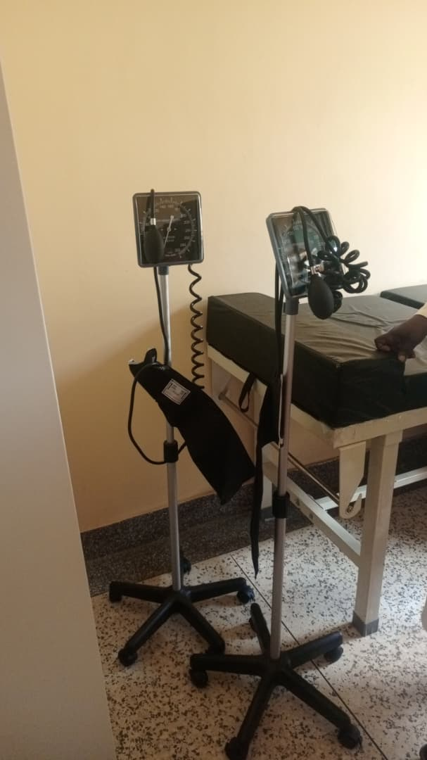
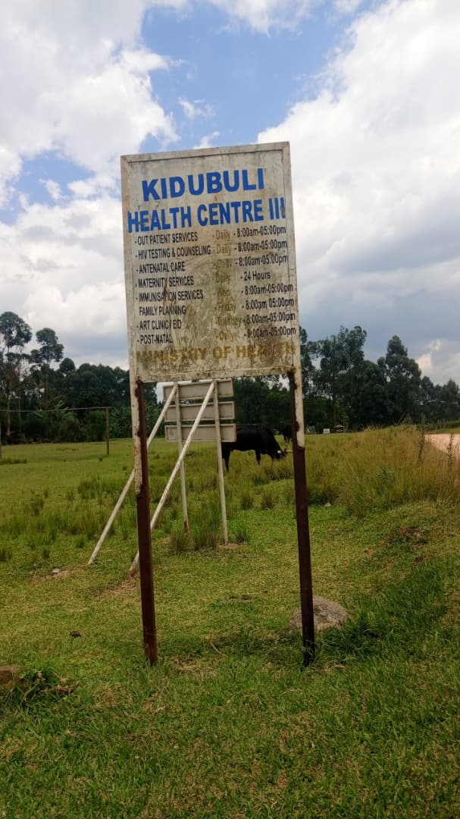
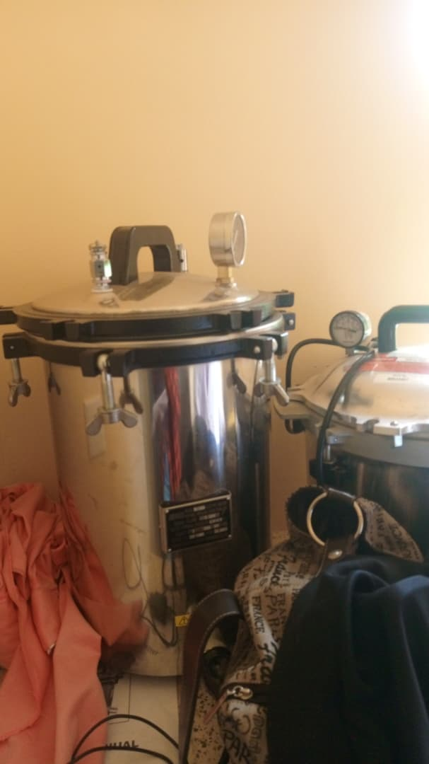

stretcher Kangaroo chair Centrifuge Hydraulic delivery bed
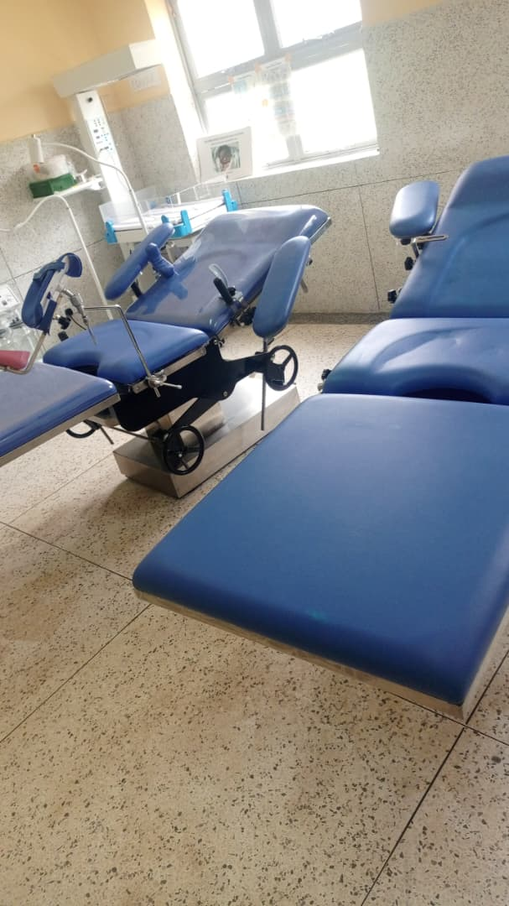
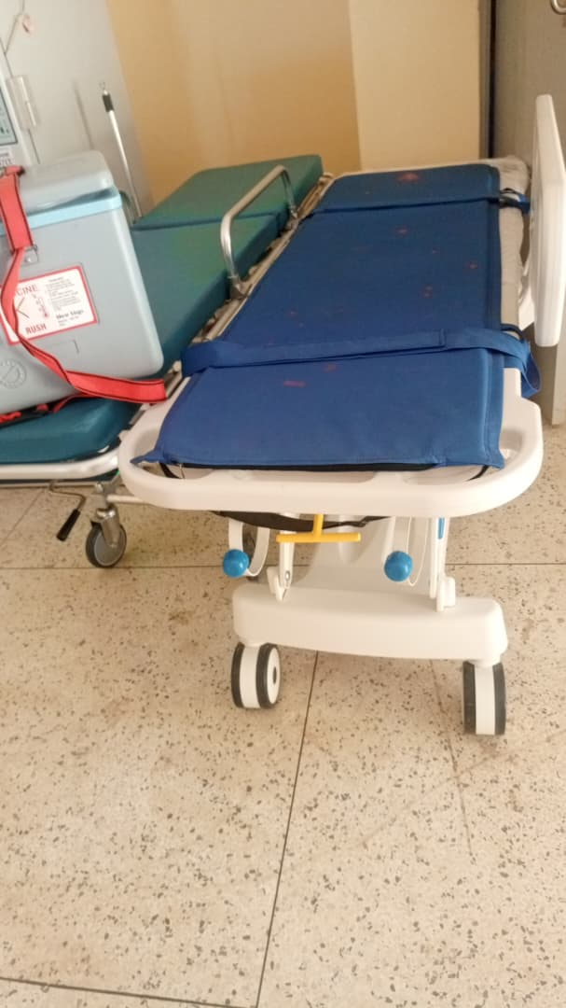
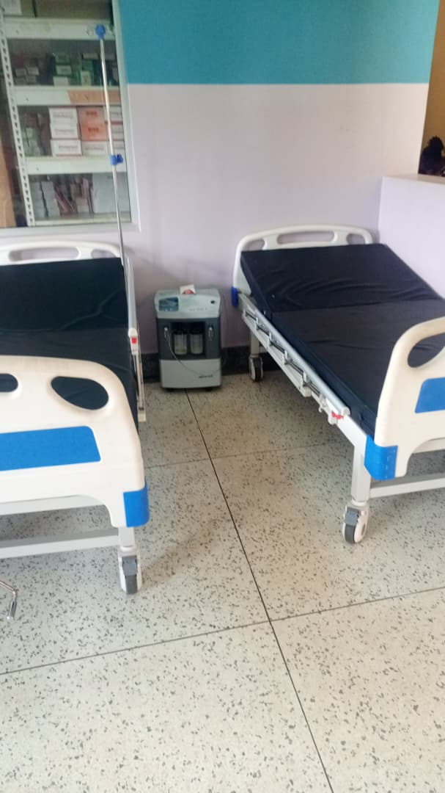
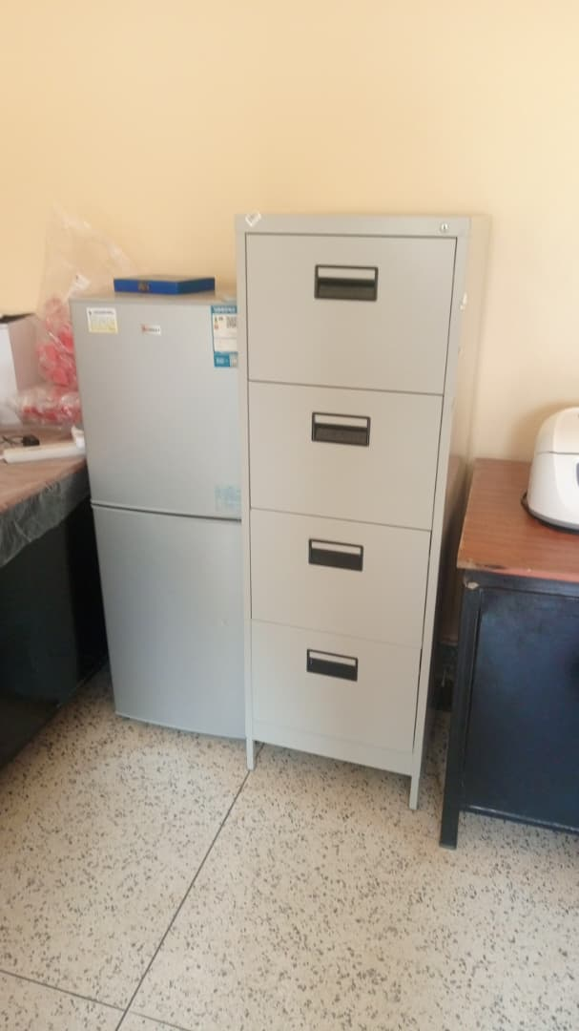
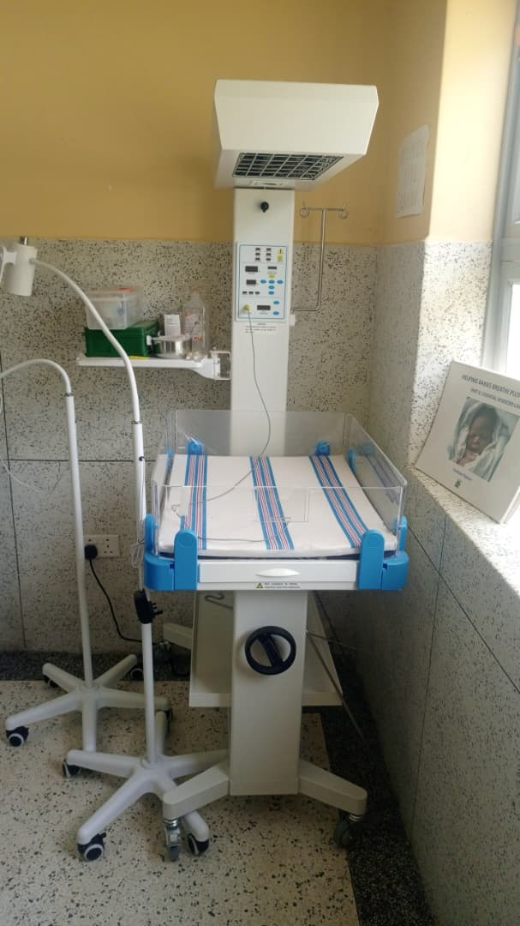
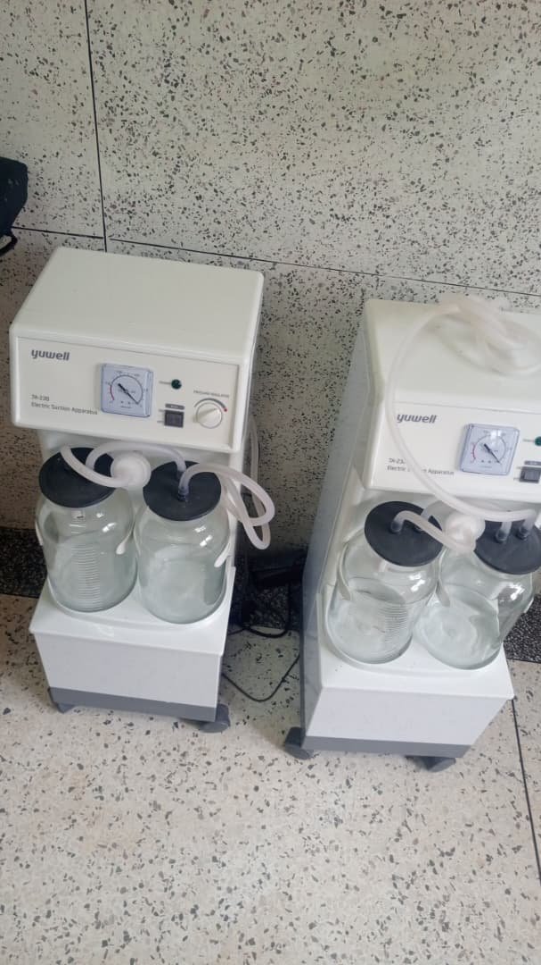
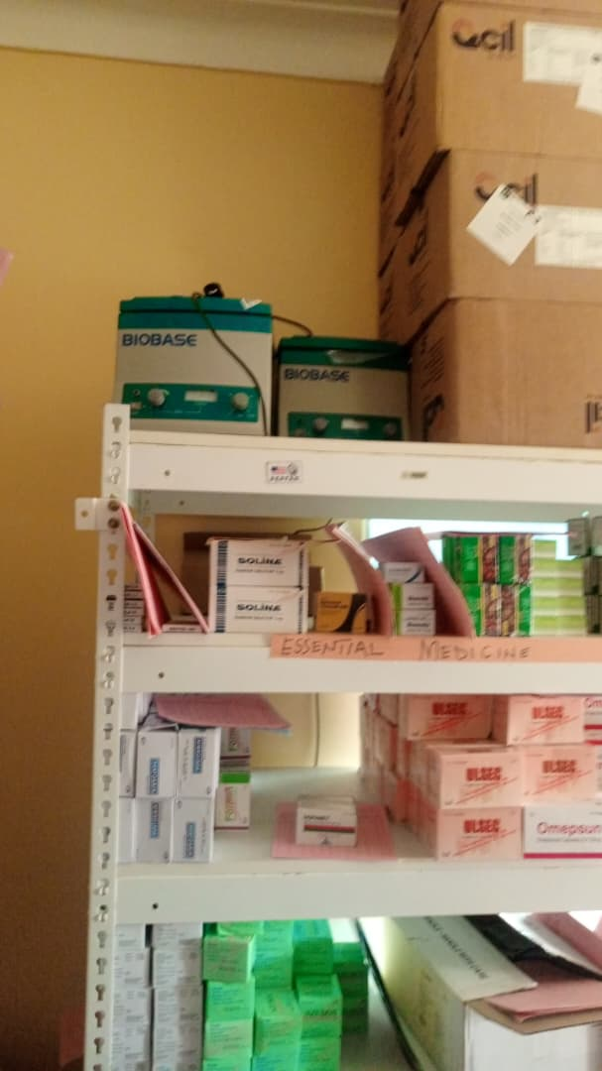
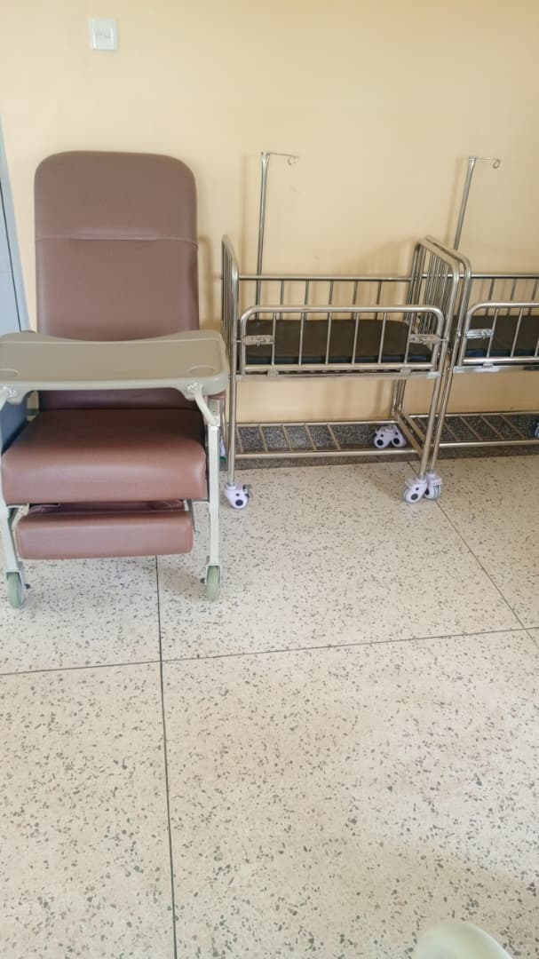

Sanction machine Radiant infant warmer Fridge and filling cabinet Patient bed

